Proposal for AAST IT Infrastructure for Carbon Reporting and VVB Establishment

# Vision

1. **For the Current Project**:  
   To establish a robust IT system for AAST University that facilitates accurate and efficient carbon footprint calculations, reporting, and continuous monitoring, ensuring compliance with international standards.
2. **For the Future Goal**:  
   To position AAST as a trusted Validation/Verification Body (VVB) capable of independently verifying and validating carbon projects, leveraging advanced technologies including AI, IoT, and remote imagery to meet local and regional market demands.

# Goals

**Current Project: Generating AAST University’s Carbon Footprint Report**

1. **Ensure Operational Efficiency**
   * Transition from manual data collection to automated workflows.
   * Streamline the calculation and reporting processes for AAST’s carbon footprint.
   * Enable real-time monitoring of emissions and energy use across campus via a dashboard.
2. **Improve Accuracy and Transparency**
   * Collect accurate and well-structured data on energy use, waste, and emissions on AAST’s campuses.
3. **Strengthen AAST Stakeholder Awareness**
   * Provide university stakeholders (faculty, students, and staff) with insights into AAST’s carbon footprint.
   * Promote sustainability initiatives adopted by AAST based on data-driven decisions.

**Future Goal: Establishing AAST as a VVB**

1. **Build a Scalable VVB IT Infrastructure**
   * Design a system that supports validation and verification of external carbon projects.
   * Ensure compliance with ISO standards and international carbon markets.
2. **Enable Advanced Verification Tools**
   * Leverage AI, IoT and other technologies to independently verify land use, emissions, and energy data for carbon projects.
   * Develop automation tools to streamline the validation/verification process.
3. **Expand Market Presence**
   * Establish AAST as a regional leader in carbon project verification.
   * Build capabilities to support both emerging and established methodologies.

# Phased Approach

The project will be implemented in **three phases**, addressing both the immediate need for AAST’s carbon footprint reporting and the long-term goal of establishing AAST as a VVB.

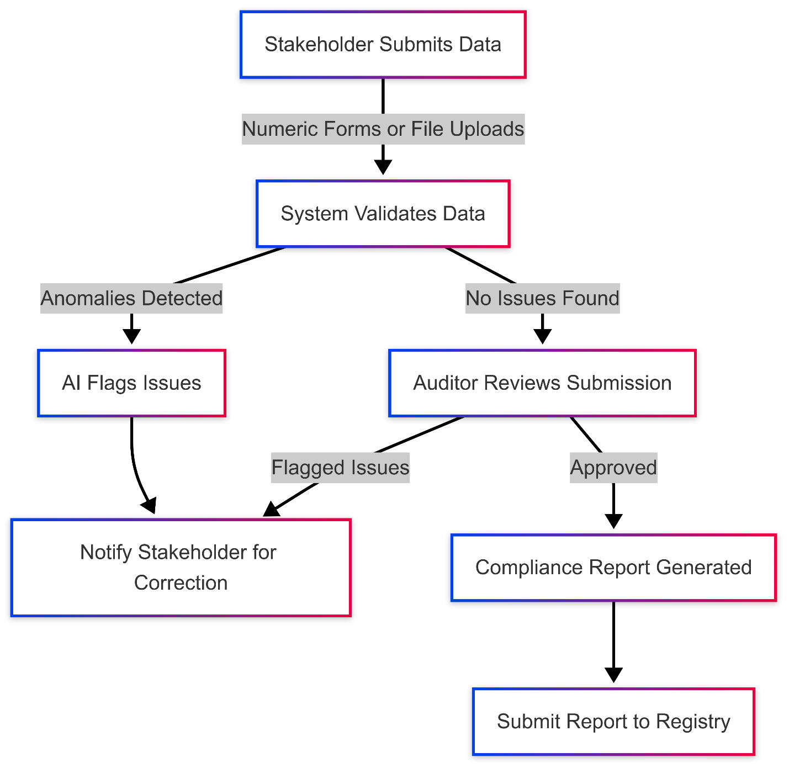

## Phase 1: Data Acquisition and Continuous Monitoring (0–4 Months)

**Focus**: Lay the foundation for efficient data collection and real-time monitoring for AAST’s carbon footprint while starting to build scalable systems for future VVB operations.

**For AAST University Carbon Reporting:**

1. **Core Data Acquisition System**
   * Centralized platform to collect energy use, emissions, waste management, and other sustainability metrics across campus.
   * Secure database with role-based access for data owners, administrators and stakeholders.
2. **Continuous Monitoring**
   * Monitoring real-time energy consumption and emissions on campus through collected data.
3. **Structured Data Submission**
   * Enable departments to submit data through user-friendly forms or batch uploads (e.g., CSV/Excel).
   * Develop APIs for automated data submission from connected systems.
4. **Role-Based Dashboards**
   * Data owners: Access and manage data as per department level.
   * Stakeholders: Access carbon footprint metrics and track sustainability initiatives.
   * Administrators: Monitor progress, generate reports, and identify areas for improvement.
5. **Automated Reporting Tools**
   * Generate carbon footprint reports in multiple formats (PDF, Excel) for internal stakeholders.
   * Provide visualizations (e.g., bar charts, pie charts) to simplify data interpretation.

**Foundation for Future VVB:**

1. **Scalable IT Architecture**
   * Design the system to accommodate additional modules for external project validation and verification for various sectors of clients (industrial, agricultural, etc.).
   * Ensure compliance with relevant standards.
2. **Stakeholder Portal**
   * Create a portal to engage stakeholders, including project developers, and share AAST’s sustainability efforts.

## Phase 2: Expansion with AI and IoT (6–12 Months)

**Focus**: Expand the system by incorporating advanced AI and IoT tools to strengthen both AAST’s internal carbon reporting and its VVB capabilities.

**For AAST University Carbon Reporting:**

1. **AI-Powered Insights**
   * Use AI models to identify outliers and inconsistencies in campus emissions data (e.g., unusual energy spikes).
   * Provide administrators with actionable insights to optimize energy usage and reduce waste.
2. **Predictive Analytics**
   * Forecast future emissions trends based on historical data.
   * Evaluate the impact of proposed sustainability initiatives.
3. **IoT Integration**
   * Expand the use of IoT sensors to monitor water usage, waste management, and emissions in real time.
   * Automate data ingestion into the reporting system.

**For VVB Establishment:**

1. **Advanced AI Models for Validation/Verification**
   * Deploy AI for outliers’ detection in external project data.
   * Use Natural Language Processing (NLP) to extract key data from project documents (e.g., emissions factors, methodologies).
2. **IoT for Remote Monitoring**
   * Enable IoT integration for external projects to collect real-time emissions data.
   * Automate data validation and flag inconsistencies for auditor review.
3. **Enhanced Dashboards**
   * Provide external stakeholders with real-time compliance feedback and project monitoring insights.
   * Include predictive insights to help project developers optimize their performance.
4. **Website Expansion**
   * Publish case studies showcasing AAST’s success in carbon reporting and VVB activities.
   * Develop interactive tools (e.g., calculators, chatbots) for stakeholder engagement.

## Phase 3: Advanced Automation and Market Integration (12–24 Months)

**Focus**: Achieve full-scale automation, integrate blockchain for smart contracts, and position AAST as a leader in carbon markets.

**For AAST University Carbon Reporting:**

1. **Advanced Automation**
   * Automate sustainability reporting workflows to ensure consistent and efficient reporting.
   * Implement smart contracts to track internal sustainability goals and automate compliance.

**For VVB Establishment:**

1. **Carbon Market Integration**
   * Develop APIs for seamless integration with carbon market platforms like Verra and Gold Standard.
   * Automate the issuance of verified carbon credits for external projects.
2. **Smart Contracts for Compliance Workflows**
   * Use blockchain-based smart contracts to automate verification workflows.
   * Example: Automatically approve projects upon meeting all validation criteria.
3. **Scalability for Emerging Methodologies**
   * Enhance the system to support new methodologies and standards in carbon verification.
   * Expand AAST’s presence in regional and global carbon markets.

# Technology Stack

| **Component** | **Technology** |
| --- | --- |
| **Frontend** | React.js for responsive user interfaces. |
| **Backend** | Python (FastAPI/Django) for scalable APIs. |
| **Database** | PostgreSQL for structured data and AWS S3 for document storage. |
| **AI Models** | TensorFlow for anomaly detection and NLP processing. |
| **Visualization** | Plotly Dash for dashboards and Google Earth Engine for geographic data analysis. |
| **IoT Integration** | MQTT protocol and IoT platforms (e.g., AWS IoT Core) for emissions monitoring. |
| **Satellite Imagery** | Google Earth Engine, Sentinel-2, or Landsat for land-use analysis. |
| **Blockchain** | Ethereum and Solidity for smart contracts. |

# Appendix: Terms and Concepts

| **Term** | **Definition** |
| --- | --- |
| **VVB** | Validation/Verification Body - An entity that validates and verifies carbon project claims. |
| **Carbon Footprint** | The total amount of greenhouse gases emitted directly and indirectly by an entity. |
| **IoT Sensors** | Internet-connected devices that monitor real-time data, such as emissions or energy usage. |
| **Smart Contracts** | Self-executing programs on a blockchain that automate workflows based on predefined conditions. |
| **NLP** | AI technology that processes text to extract relevant information, such as emissions factors or project details. |